**Dune - Sprint 6.2 retrospective**

**What worked well:** We had merge conflicts but we were able to resolve them very quickly and efficiently, it was good to learn that we can deal with stuff like that as a team.

**What didn’t work well:** We didn’t get everything done this sprint that we wanted. We didn’t have great standup meetings this week.

**What we can change for next week:** Next week we can do a better job estimating tasks and put more details into our standup meetings.

**Backlog grooming/refining time estimate:** 1hrs

**Sprint plan for next week:**

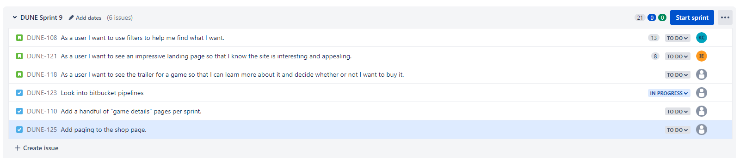

**Story points last sprint:** 151

**Story points next sprint:** TBD